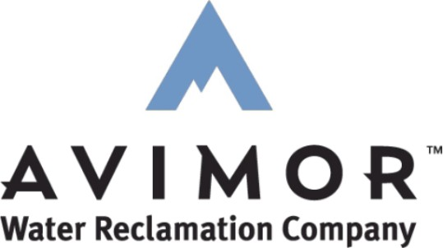
Avimor Water Reclamation Company, LLC
PO Box 94154
Seattle, WA 98124

Customer Service
(971) 703-4242
customerservice@puttman.com

www.puttman.com

2026 Rate Schedule

Property Resales

AWRC Sewer & Irrigation Rates & Fees:
Quarterly rate for sewer and irrigation service.

Single Family Residential Sewer Rate: $214.50 EDU/quarter
Multi-Family Residential Sewer Rate: As determined by EDU
Commercial Sewer Rate: As determined by EDU

Irrigation Base Rate (3/4” meter): $8.25/month
Irrigation Volumetric Rate: $1.62/CCF

Account Transfer Fee: $200
Electronic Payment Processing Fee: 3% ($2.25 minimum)
Inspection Fee: $150
E-Locate: $100
Call Out: $100
Fats, Oils, and Grease (FOG) Fee: As determined by use
Late Fee: $20/month

ARCA / ASO Fees:
The following fees apply to all Avimor properties:

Avimor Residential Community Association (ARCA): $286.50/quarter
Avimor Stewardship Organization (ASO): $38.35/quarter
ARCA Account Transfer Fee: (applies to all ownership transfers) $150
ARCA Reserve Fee: (applies to all ownership transfers) $1,000

The following fee also applies to all Boise County and all Gem County properties:
ARCA Boise & Gem County Road Maintenance & EMS Fee: $86.20/quarter

The following fees also apply to all Townhome properties:
Avimor Townhome Supplemental Assessment (ATSA): $24.40/quarter
Avimor Townhome Reserve Account Assessment (ATRAA): $238.70/quarter

Billing Frequency:
Service is billed quarterly. Quarterly invoices will be mailed each January, April, July, and October at the beginning of each month and payments are due by the 20th of the month.

